Using The Smart Response System in Your Classroom

The Hardware:

Your Smart Response Clickers are easy to use.

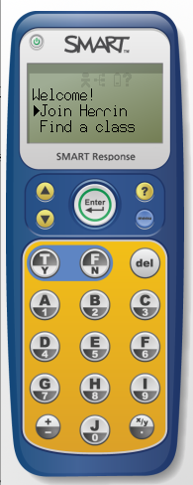
The Power Button
The Viewing Screen
Scroll Up or Down on Viewing Screen
Enter class or answer choices you have selected
Answer keys
Menu button: for choosing a language or signing out

The Smart Response Receiver plugs in to a USB port on the back of your computer. It’s this blue receiver in the bag☺
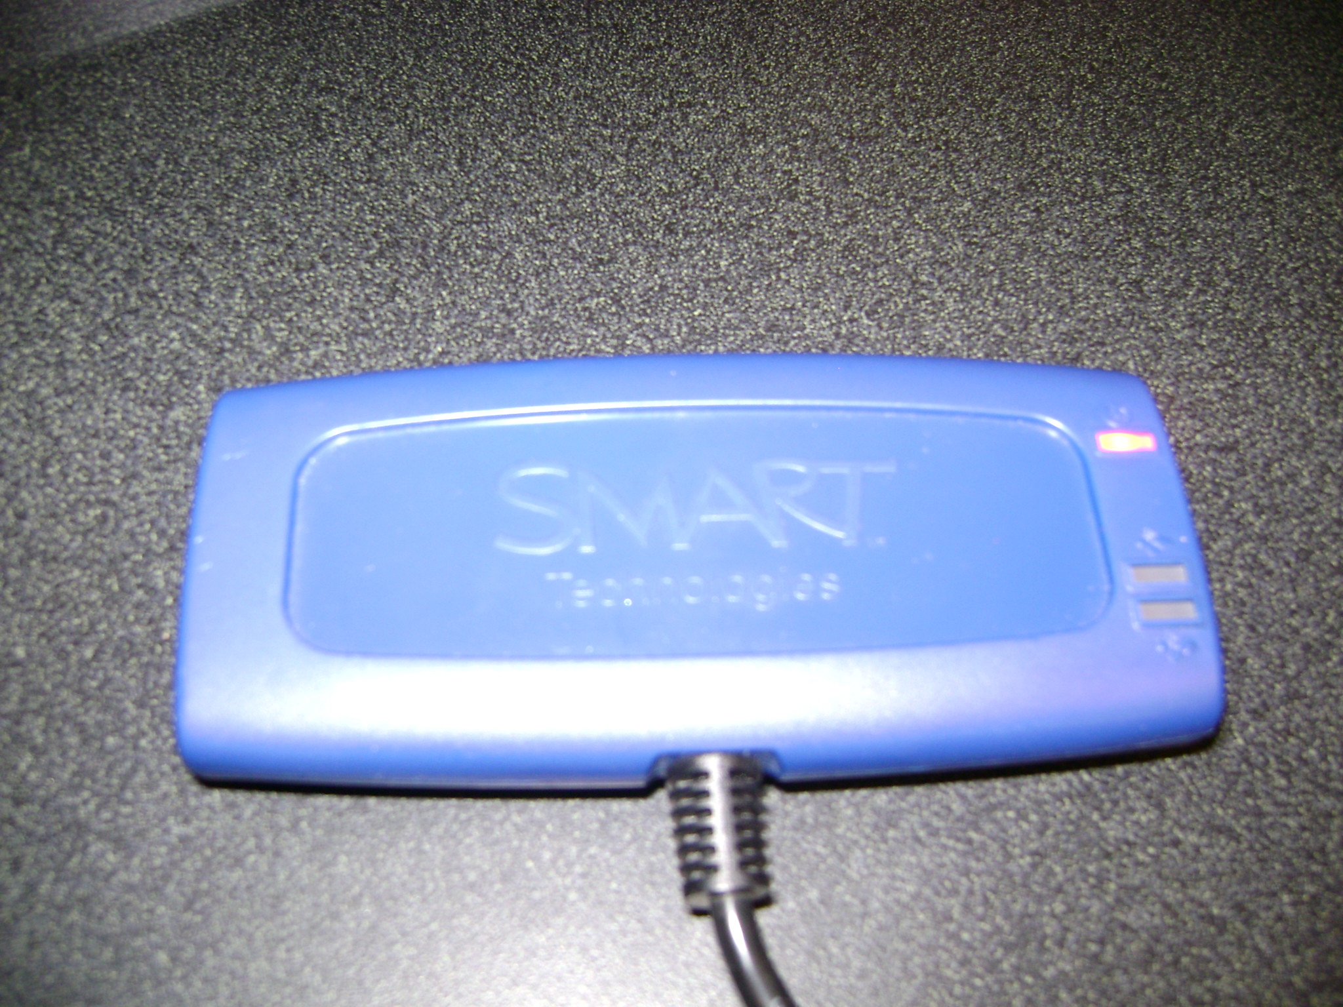

The Software:

The following is a discussion of the software that accompanies the Smart Response System. This software is already loaded on our machines and housed on the dock for you to access. I have found, in my Mac school, that it only works correctly when logged in as admin or localuser/localuser. So that is what we are all doing.

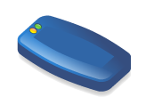Response Hardware Service

The status light on the receiver you plugged in will be red. Double-click on the Response Hardware Service icon in the dock. This service will make your computer recognize the Smart Response receiver and the red status light should go green. * You can hold down your control key on a Mac and set this to open at log in just like you did with your Smart Board Service.

 Teacher Tools

This application allows you to access, view, and manage all of your student data. This is where you create classes, add students, and manage your assessments. To get started with your Smart Response, you need to set up your Teacher Tools:

- Click on the Teacher Tools icon in the dock to launch.

- Type a name for your classroom when prompted. If you’ve forgotten to hook the receiver in to a USB port, you will be prompted to connect it at this point. You cannot move on until the receiver is in the USB port and active.

- You can see that you are in Anonymous Mode (which is the default) and your Classroom name will show. Note the other information on this screen:

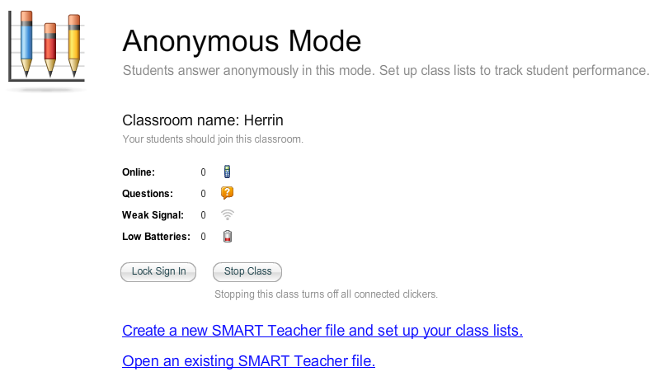
*If you turn a Smart Response clicker on right now, you will see the 0 beside Online change to 1☺
It’s that easy to get started.

At this point, you are ready to function in Anonymous mode. You could hand out the Smart Response clickers, have students cut them on, and open a Notebook file with prepared questions and begin. You would simply click on Open an existing SMART Teacher file.

Setting Up Class Lists

While anonymous mode is great for quick feedback and reviews, if you want to seriously keep up with your assessment of students, then you will want to Create a new SMART Teacher file and set up your class list. This option is highlighted in the next screen shot.

Once you click on this option, you will get your Grade book Information window, and you can enter your name and school:

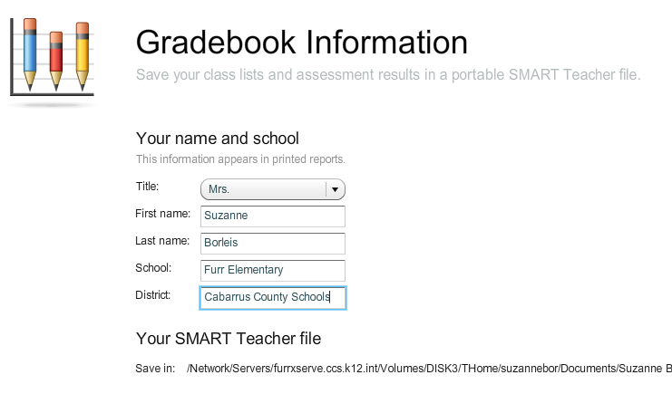
Click “Done” when you are finished! It’s at the very bottom of the screen☺

Your Grade Book is now set up. Let’s see what options the next window gives you:

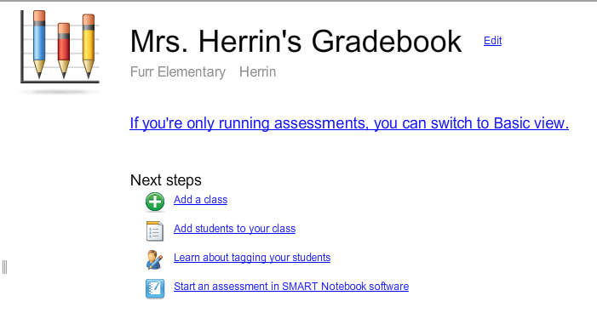

From this point, you have several options. Take a moment to look at the above screen shot to see what these are.

Today, let’s choose add a class. I want you to see how to get students in to the Teacher Tools Software.

- Click on Add a Class.
- Fill in your class information and click Add.

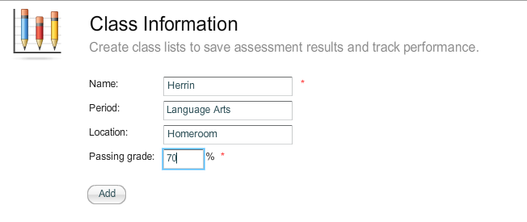

- Now, let’s add students.

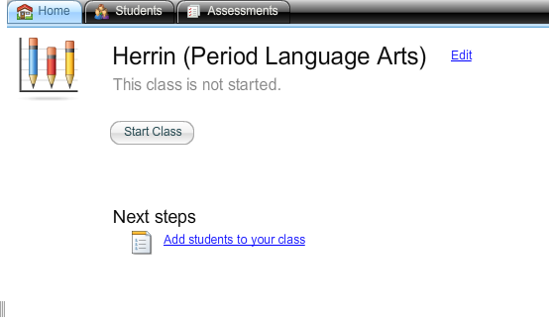
Note that this class is not started. If a class is started, you cannot edit the student list. So make sure your class is not started.

4. Now you can choose what class to import students in to:

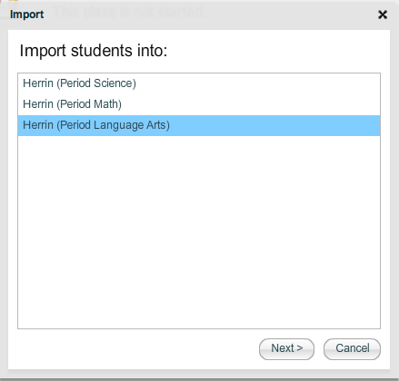
Select your class and hit Next.

- And now the Teacher Tools program wants you to import your students. Don’t be frightened! I’m going to show you how to make a .csv file in Excel. When you come back to Teacher Tools, choose the option below: Comma Separated Values (CSV).

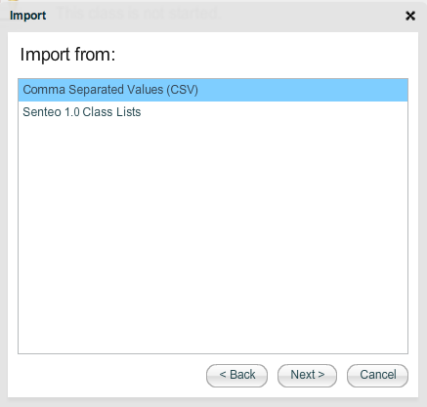

Making Your Student Import Spreadsheet.

- Open Excel. 
- Set your excel spreadsheet up to look just like this one:

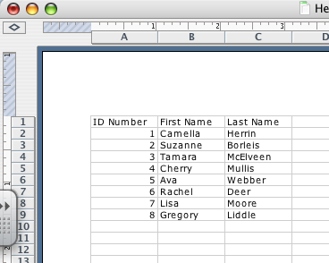
You can use their NC Wise ID numbers, that is fine, or just assign them a number. * Make your headings at the top of each column look just like mine.

3. Now go to File and save this spreadsheet as a Comma Delimited File.

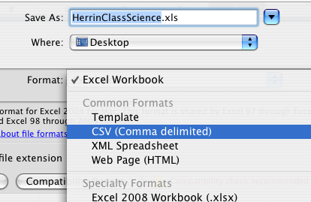
It looks like this…

4. You may get messages about formatting, just keep saying yes or ok.

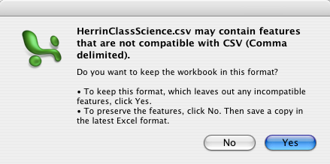
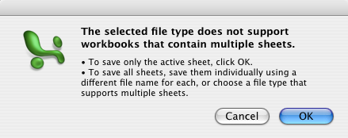

- Now you have your import file ready. I like to save mine to the desktop for easy retrieval.

Creating Assessments

If you’ve just imported your students, you will come to this screen:

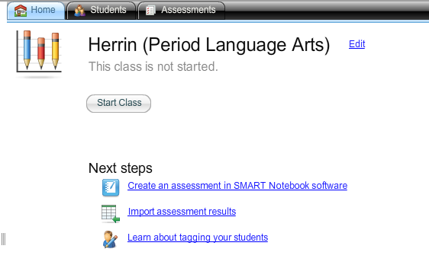
Note, you can click on the Students tab to see all the kids you just imported if you like. Check to make sure they are there now.

You can choose to Create an assessment in SMART Notebook Software, and it will open Notebook for you to begin.

Using Notebook to Create Smart Response Assessments

You will most likely see this message the first time you open Notebook up with the intention of using your Smart Response System: check the box beside Automatically perform the selected action from now on, and then say Yes!

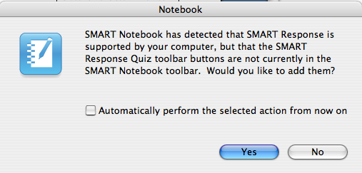

- Notice you have some new buttons and tabs in Notebook because you said yes to the window above.

  - These buttons are now on the toolbar, they allow you to insert a question or start an assessment.

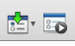
  - This tab will now appear below the Page Sorter, Gallery, and Properties tabs. It allows you to totally create, start, and stop an assessment:

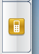

2. So Click on the Smart Response Tab, and Get Started!

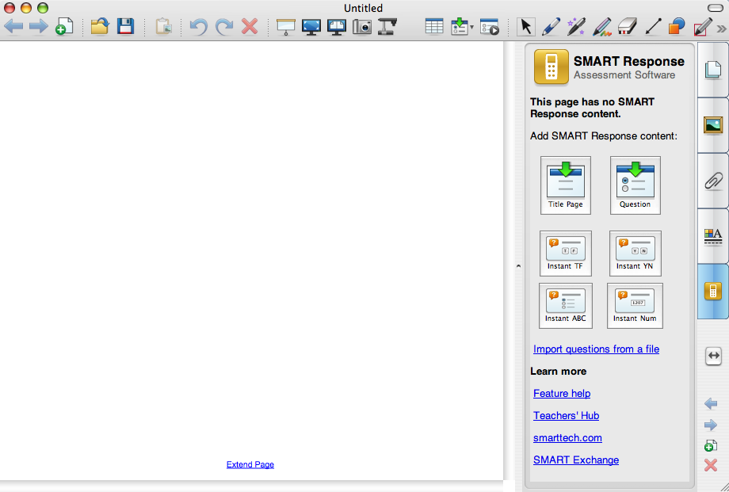

3. Make your Title Page first-asks you to fill out the information that will then show in your Teacher Tools Grade Book:

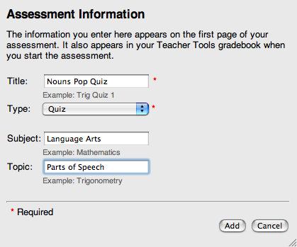

Once you have this title page filled out, you will get the next screen. You can see that this is where you begin inserting questions (one per slide) and start/stop your assessments:



